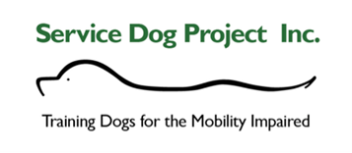
BOARD OF DIRECTORS
2023

Chip Maurer, Treasurer | General Manager at Carlysle Engineering in Boston MA. 30 years of commercial construction management experience. SDP volunteer for 5 years.
Jennifer Fitzpatrick, Chairperson | Commercial insurance Account Manager for Chalmers Insurance group in York, ME. SDP volunteer for 2+ years.
Katherine Bailey, Officer | Founder and director of a charitable foundation that supported the well-being and care of hospitalized children.
Lynn Wronkowski, Secretary | Retired Human Resources professional and lover of the Great Dane Breed. SDP volunteer for 2+ years.
William Toto, Officer | Self-employed and working as a licensed Home Inspector in the State of New Hampshire. After being honorably discharged from the United States Marine Corps, (12 years of service) he went on to serve his community as an Emergency Medical Technician. He has been involved with SDP for just over 4 years and is the recipient of "Paula" who after delivering 8 beautiful puppies, is now a retired breeder.

